**Transfer Learning for Image Classification**

Dataset and Pre-Trained Model Selection:

Dataset: CIFAR-10 is chosen for this task, which consists of 60,000 32x32 color images in 10 different classes.

Pre-Trained Model: VGG16 is selected as the pre-trained model for transfer learning.

Exploratory Data Analysis (EDA):

1. Class Distribution: Checked the count of target classes and visualized it in a bar chart.

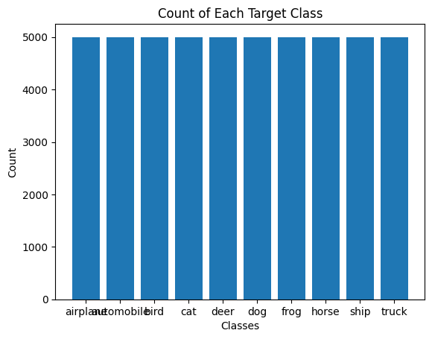

1. Sample Images: Displayed one image of each class with its class name.

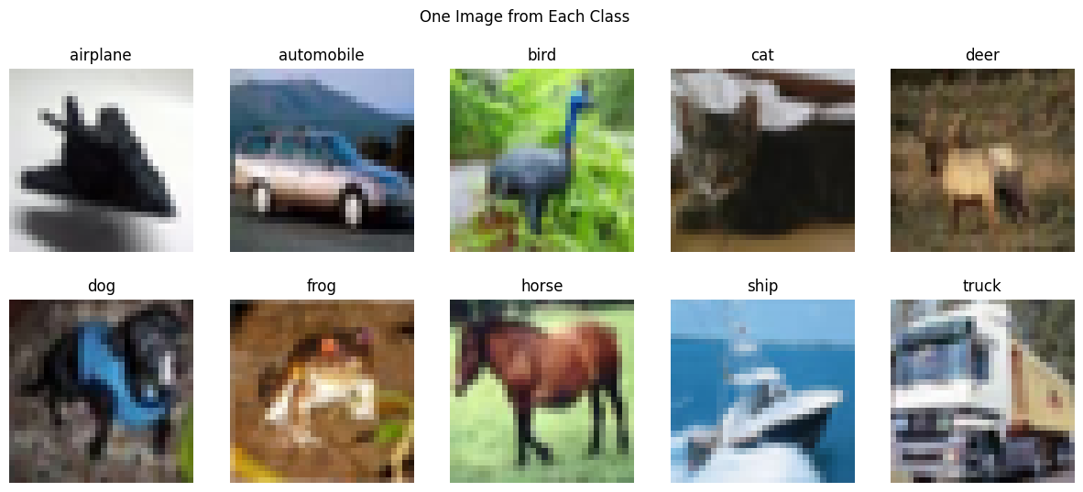

Preprocessing the Dataset:

1. Normalization: Pixel values are normalized to a range of [0, 1].

2. One-Hot Encoding: Target labels are one-hot encoded.

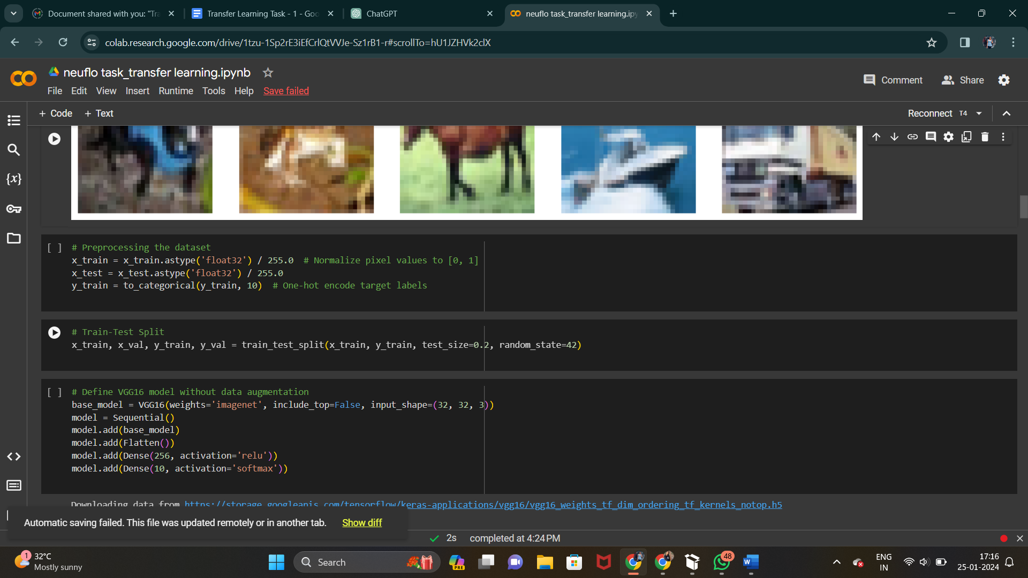

Image Augmentation:

Tried the ImageDataGenerator function in Keras to augment images for training. First, trained the pre-trained model without augmentation, then with augmentation. Choose the model with the best performance.

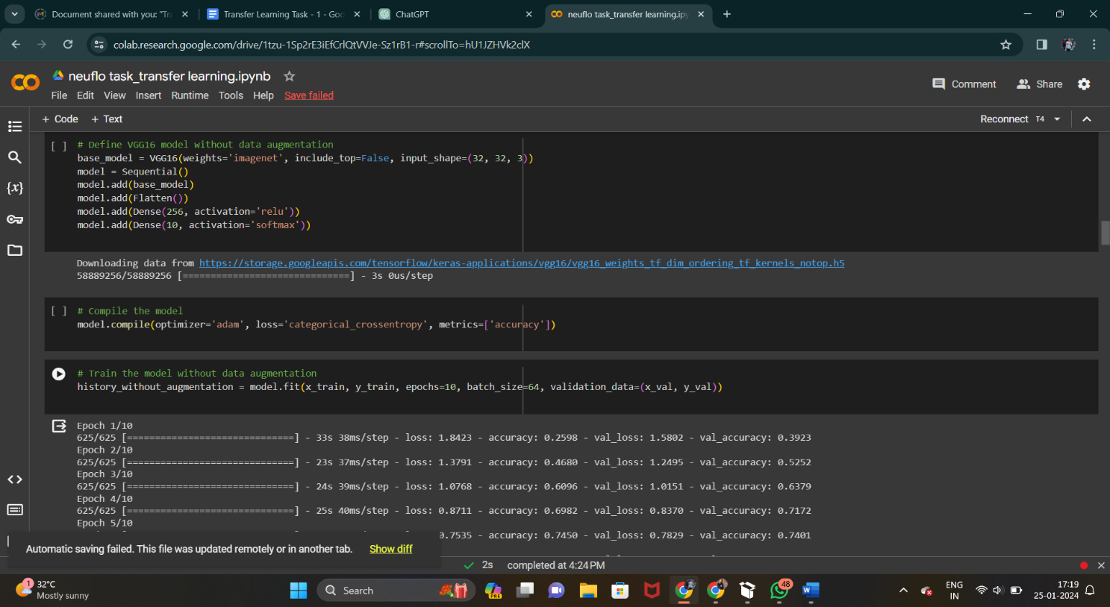

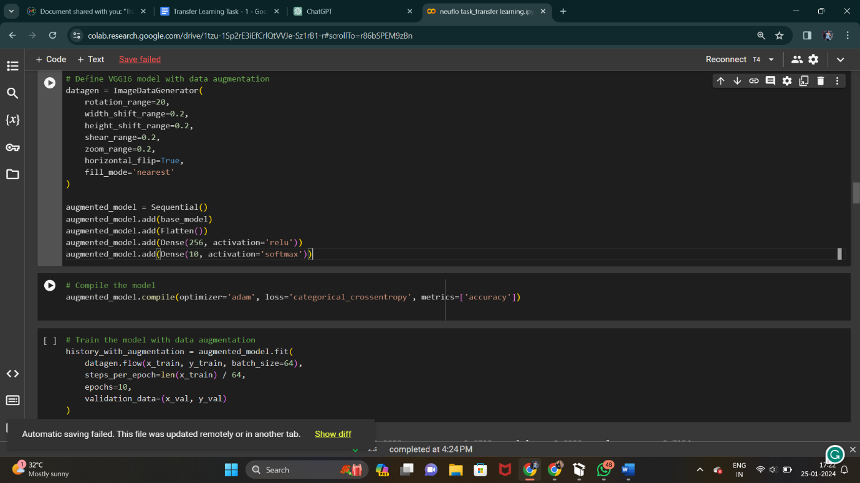

Model Training & Evaluation:

1. Training from Scratch:

Trained the model from scratch (e.g., VGG16 loaded with weights=None) for a maximum of 100 epochs.

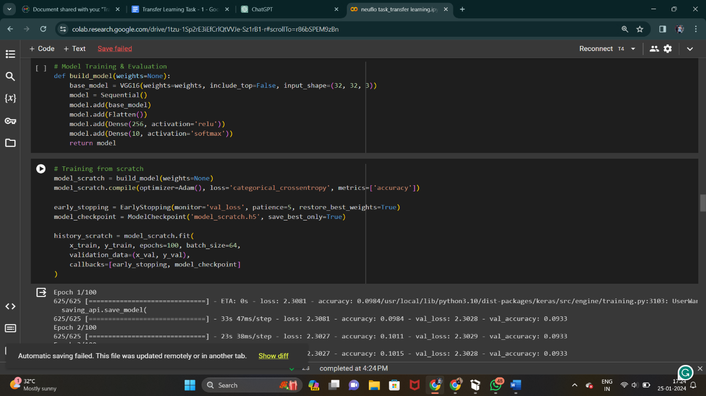

2. Transfer Learning:

Trained the model with pre-trained weights (e.g., VGG16 loaded with weights="imagenet") for a maximum of 100 epochs.

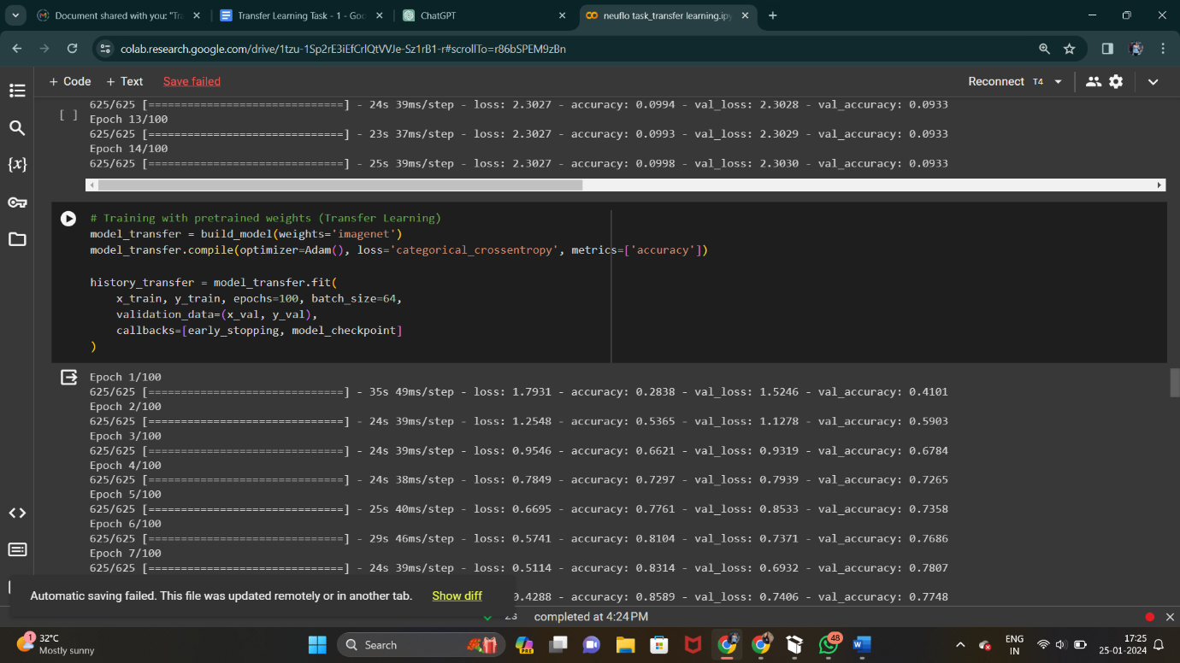

3. Freezing/Unfreezing Layers:

Experimented with freezing and unfreezing layers in the model.

Plotted learning curves.

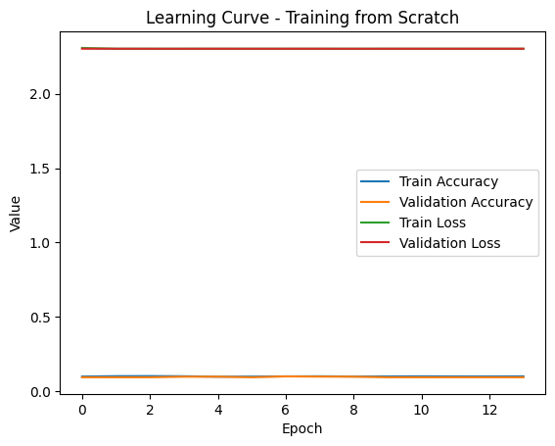

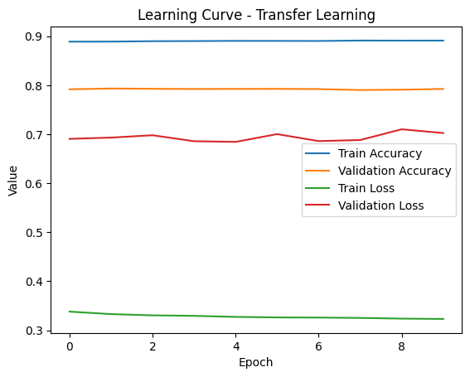

Observations:

1. Training Without Data Augmentation:

* Achieved a test accuracy of 77.54% after training for 10 epochs without data augmentation.

2. Training With Data Augmentation:

* Achieved a higher test accuracy of 81.77% after training for 10 epochs with data augmentation.

3. Training From Scratch:

* Training from scratch with 100 epochs did not yield good results. The accuracy was low (10%) and the model seemed to struggle to learn.

4. Transfer Learning (Pre-Trained Weights):

* Training with pre-trained weights (Transfer Learning) resulted in a better performance, achieving a test accuracy of 79%. This demonstrates the effectiveness of transfer learning in improving model performance, especially with limited data.

5. Freezing/Unfreezing Layers:

* Freezing and unfreezing layers were experimented with during transfer learning. Freezing certain layers and fine-tuning others can be beneficial, especially when working with pre-trained models.

6. Classification Reports:

* Classification reports were displayed for models trained with and without data augmentation, showing precision, recall, and F1-score for each class.

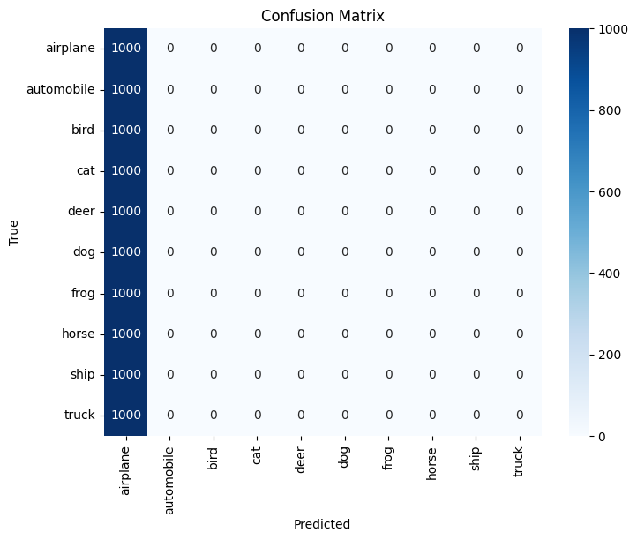

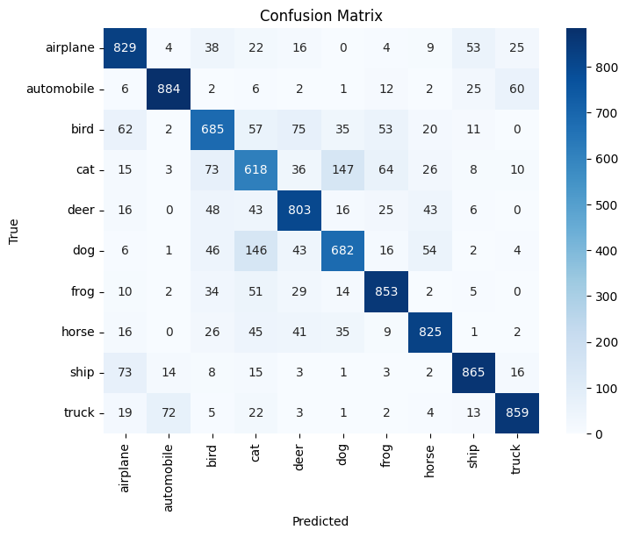

Conclusion:

* Data augmentation, transfer learning, and freezing/unfreezing layers can significantly impact the performance of an image classification model.
* Transfer learning with pre-trained weights tends to outperform training from scratch, especially in scenarios with limited data.
* Freezing certain layers during transfer learning helps in retaining useful features learned by the pre-trained model.
* Data augmentation contributes to better generalization by exposing the model to variations in the training data.

1. What is Transfer Learning?

Transfer learning is a machine learning technique where we leverage knowledge gained from solving one task and apply it to a different but related task. Instead of starting the learning process from zero for a new task, we use the insights and features learned from a model trained on a similar task. It's like using previously acquired knowledge to improve learning efficiency for a new challenge.

2. What are Pretrained Models?

Pretrained models are like smart students who have already learned a lot. These models are trained on massive datasets for tasks like image recognition. Instead of training a model from scratch, we can use these pretrained models and adapt them for our specific task.

3. Benefits of Using Pretrained Models:

Faster Learning: Pretrained models save time and resources.

Better Performance: They have already learned useful features from vast datasets.

Works with Less Data: Helpful when you don't have a huge dataset.

4. Transfer Learning vs. From Scratch:

Transfer Learning: Uses knowledge from a related task. Faster learning, and better performance.

From Scratch: Starts with no prior knowledge. Needs more data and time.

5. Freezing and Unfreezing in Transfer Learning:

Freezing: Locks some layers of the pretrained model. Keeps the learned features intact.

Unfreezing: Allows training on certain layers. Helps adapt the model to new tasks.

6. Model Architecture:

VGG16 Architecture: VGG16 is a deep neural network with multiple convolutional layers. Each layer detects different features, like edges or textures. The final layers combine these features for accurate predictions.

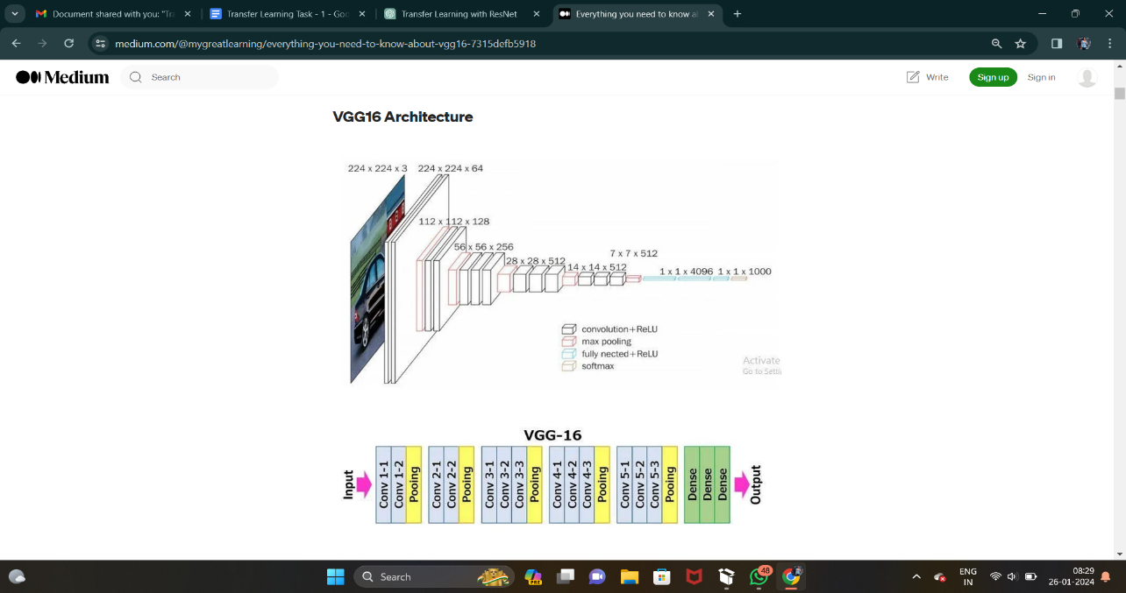

* The 16 in VGG16 refers to 16 layers that have weights. In VGG16 there are thirteen convolutional layers, five Max Pooling layers, and three Dense layers which sum up to 21 layers but it has only sixteen weight layers i.e., learnable parameters layer.
* VGG16 takes input tensor size as 224, 244 with 3 RGB channel
* Most unique thing about VGG16 is that instead of having a large number of hyper-parameters they focused on having convolution layers of 3x3 filter with stride 1 and always used the same padding and maxpool layer of 2x2 filter of stride 2.
* The convolution and max pool layers are consistently arranged throughout the whole architecture
* Conv-1 Layer has 64 number of filters, Conv-2 has 128 filters, Conv-3 has 256 filters, Conv 4 and Conv 5 has 512 filters.
* Three Fully-Connected (FC) layers follow a stack of convolutional layers: the first two have 4096 channels each, the third performs 1000-way ILSVRC classification and thus contains 1000 channels (one for each class). The final layer is the soft-max layer.

7. Learning Curves:

Training Curve: This shows how well the model learns over epochs.

Validation Curve: Shows performance on a separate set. Helps detect overfitting (memorizing, not learning).

8. One-Hot Encoding vs. Label Encoding:

One-Hot Encoding: Turning categories into binary vectors. Each category becomes a unique combination of 0s and 1s.

Label Encoding: Assigning a unique number to each category. Less expressive but simpler for machines.